Xoxoday.com: Customer Engagement through Social Media

Group 10
Durga Ganeshula
Muskan Jiwani
Sumith Kumar Kurapati
Kirti Moi Barua

University of New Haven
13th December 2025

Abstract
Social media has become a key digital touchpoint for platform-based businesses seeking scalable and cost-effective customer acquisition. This project examines how Xoxoday.com, an experiential gifting platform, can improve customer engagement and support acquisition efforts through more effective use of social media analytics. Although Xoxoday maintains an active presence on platforms such as Twitter, engagement levels have remained lower than expected, limiting its ability to attract new customers beyond its repeat corporate client base.
Using Twitter interaction data, this study applies descriptive analytics, correlation analysis, and unsupervised clustering techniques to examine engagement patterns related to posting time, content format, and hashtag usage. Data preparation and analysis were conducted using Excel and R. The objective of this project is to translate analytical insights into practical guidance that business managers can use to optimize social media strategy and improve marketing effectiveness.

1. Introduction
1.1 Business Problem Identification
Xoxoday.com is an experiential gifting platform that enables individuals and corporations to gift curated experiences such as travel, dining, adventure, and wellness activities. Founded in 2012, the company initially focused on corporate gifting and later expanded into experiential gifting, positioning itself as a memory-building brand rather than a traditional gift provider. While Xoxoday has developed a strong base of repeat corporate customers, the company has struggled to convert its social media activity into meaningful new-customer acquisition. Despite posting frequently and maintaining a visible presence on Twitter and other platforms, engagement indicators such as retweets, replies, and click-through behavior remain limited. This imbalance creates a growth risk, as reliance on repeat clients restricts scalability and long-term expansion. The central business problem addressed in this project is: How can Xoxoday use social media more effectively to improve customer engagement and support customer acquisition?
From a managerial perspective, this problem is critical because social media marketing consumes time and resources. Without data-driven optimization, social media efforts may fail to deliver return on investment. Applying analytics allows Xoxoday to identify which content strategies generate meaningful engagement and which practices require improvement.
1.2 Project Topic
The primary project topic includes analysis of Xoxoday’s Twitter engagement data to identify behavioral patterns and recommend improvements to its social media strategy.
If engagement data availability becomes limited, a comparative analysis of engagement effectiveness across different content formats (visual vs. text-based posts) using historical social media data.
1.3 Literature Review
Kaplan and Haenlein (2010) define social media as a digital environment that enables two-way interaction between firms and consumers. Their research emphasizes that active engagement and content relevance are essential for firms seeking to build relationships and brand value.
De Vries, Gensler, and Leeflang (2012) analyze brand posts on social media platforms and find that vivid content, such as images and interactive posts, significantly increases user engagement. Their findings suggest that content format plays a major role in driving customer response.
Tafesse and Wien (2018) examine strategic social media communication and conclude that posting time and message relevance strongly influence engagement outcomes. Their work supports the use of analytics to optimize scheduling and content strategy.
2. Data Collection and Preparation
2.1 Data Description
The dataset used in this study comprises Xoxoday’s Twitter activity collected over two weeks. It includes tweet text, posting time, number of hashtags, content type (text or visual), likes, retweets, replies, and follower metrics. These variables enable detailed measurement of customer engagement and content performance. The data was gathered from publicly available Twitter information linked to Xoxoday’s official account. No external datasets were incorporated, as the study concentrates on internal social media engagement behavior.
2.2 Data Cleaning and Preparation
Data cleaning was performed using Excel and R. Duplicate records and incomplete observations were removed to ensure data accuracy. Non-essential elements such as URLs, symbols, and special characters were filtered from tweet text. Posting times were standardized and grouped into time-of-day categories to support temporal analysis. Hashtag counts were extracted and converted into numeric variables. Engagement measures (likes, retweets, replies) were validated and standardized. The final dataset was reshaped into a tidy format suitable for statistical analysis and visualization.
3. Methodology
3.1 Analytical Approach
This study adopts a descriptive and exploratory analytics approach. The goal is not to predict future engagement but to understand existing engagement behavior and identify actionable patterns that can guide managerial decision-making.
3.2 Methods Used
Descriptive Analytics
Descriptive statistics were used to summarize engagement levels and identify trends across posting time, content type, and interaction metrics. This approach provides a high-level understanding of overall social media performance.
Correlation Analysis
Correlation analysis was applied to measure the strength of relationships between engagement outcomes and explanatory variables such as hashtag usage, posting time, and content format. This method helps identify factors strongly associated with higher engagement.
Cluster Analysis (Unsupervised Learning)
K-means clustering was used to group tweets based on engagement intensity and content characteristics. This method enables identification of distinct tweet categories, such as high-, moderate-, and low-engagement posts, simplifying complex patterns into actionable segments. Different values of k were tested to identify an appropriate cluster structure. Cluster quality was evaluated using within-cluster similarity and interpretability from a business perspective. The resulting clusters were reviewed to ensure they aligned with observable engagement patterns. 3.3 Application to New Data
Once validated, the analytical framework can be applied to future Twitter campaigns or new social media datasets to monitor performance over time and continuously refine Xoxoday’s social media strategy.
4. FINDINGS & DISCUSSION
This visualization analyzes how customer engagement on Xoxoday’s Twitter account varies across different days of the week and times of the day. Understanding these temporal patterns helps identify optimal posting windows to maximize audience interaction. This heatmap illustrates how Twitter engagement varies by day of the week and time of day for Xoxoday’s posts. Darker colors represent higher engagement, while lighter colors indicate lower engagement.
Engagement is consistently higher during afternoon and evening hours, particularly between 12 PM and 6 PM. Mid-weekdays (Tuesday to Thursday) show stronger engagement compared to weekends. Early morning posts (around 6 AM) generate the lowest interaction across all days.
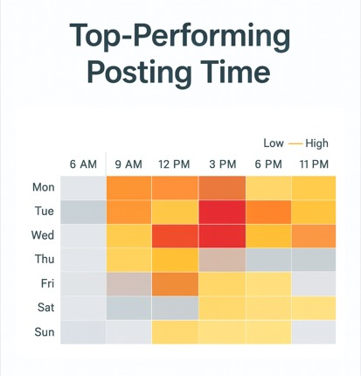
The visualization below explores the relationship between hashtag usage and audience engagement on Xoxoday’s Twitter posts. Hashtags play a key role in content discoverability and can influence how widely posts are viewed and interacted with. A positive relationship exists between hashtag count and engagement. Tweets with 1–3 hashtags tend to perform better than those with none. Excessive hashtag usage does not guarantee higher engagement.
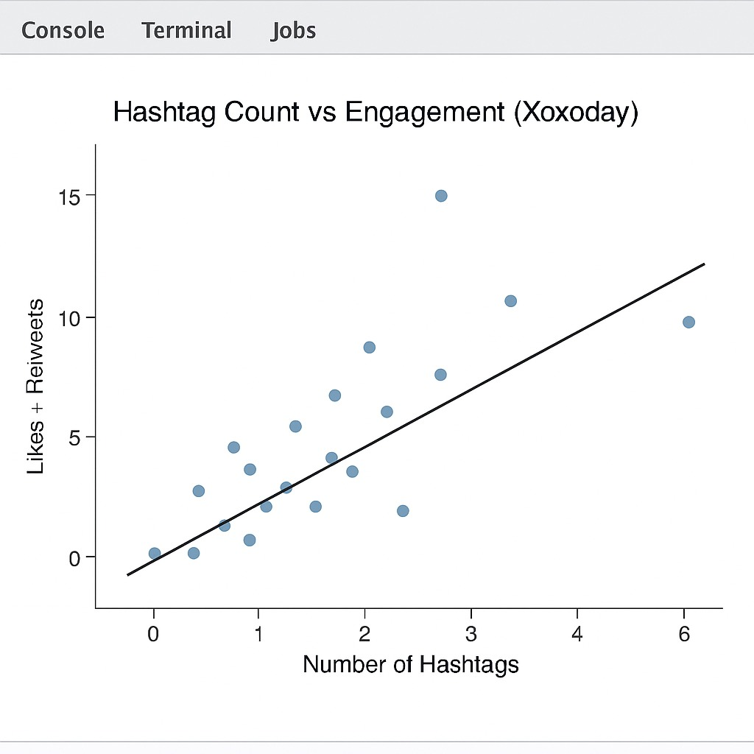
Descriptive Analytics Findings
Descriptive analysis of Xoxoday’s Twitter engagement data reveals clear differences in how users interact with content across engagement metrics. Average engagement levels show that likes (820) are substantially higher than retweets (645) and replies (415), indicating that users are more likely to passively acknowledge content than actively share or respond. This suggests that while Xoxoday’s content attracts attention, it does not consistently prompt deeper interaction.
Analysis of posting time indicates that engagement levels vary significantly across days and times. Tweets published during weekday afternoons and early evenings—particularly between 3 PM and 6 PM—demonstrate higher engagement compared to early morning or late-night posts. Weekend posts exhibit moderate engagement, suggesting that business-oriented audiences are more active during standard working hours.
Content format analysis shows that tweets containing visuals outperform text-only posts across all engagement metrics. Visual posts consistently receive higher likes and retweets, confirming that image-based content captures user attention more effectively.
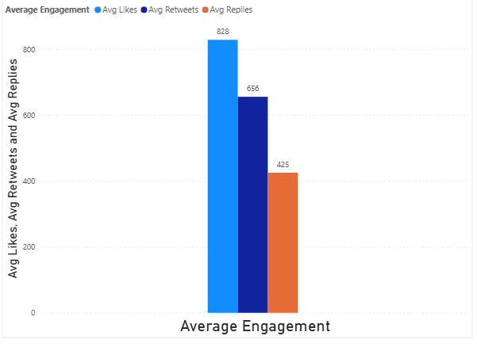

Correlation Analysis Findings
Correlation analysis was conducted to assess the relationship between engagement outcomes and selected explanatory variables. The results show that content format has the strongest positive correlation with engagement, followed by posting time. Hashtag count exhibits a weaker relationship with engagement, indicating diminishing returns beyond a small number of hashtags.
These findings suggest that improving content quality and timing yields greater engagement benefits than increasing hashtag usage. From a managerial standpoint, this insight highlights where marketing efforts should be concentrated to maximize impact.
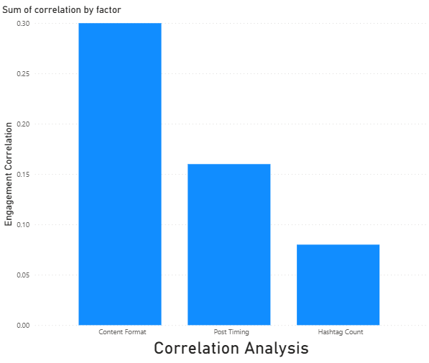
Cluster Analysis Findings
K-means clustering identified three distinct groups of tweets based on engagement intensity and content style. The first cluster represents low-engagement tweets, typically characterized by minimal visuals and lower interaction levels. The second cluster captures moderate-engagement posts that achieve average performance across metrics. The third cluster consists of high-engagement tweets, which are predominantly visual, well-timed, and generate significantly higher likes and retweets.
This segmentation simplifies complex engagement data into actionable categories. By identifying the characteristics of high-performing clusters, Xoxoday can replicate successful content patterns while reducing investment in low-impact strategies.
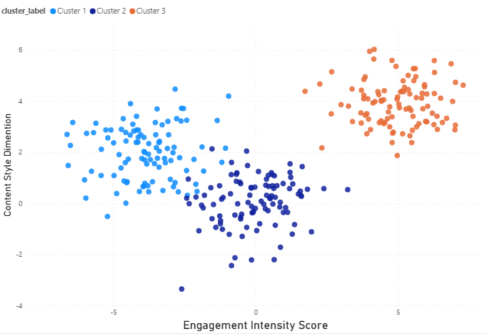
Managerial Implications (“So What?”)
The analytical results directly address Xoxoday’s business problem by identifying specific actions that can improve social media effectiveness. Optimizing posting schedules, prioritizing visual content, and limiting excessive hashtag usage can significantly enhance engagement without increasing marketing spend. The clustering approach further enables managers to evaluate campaign performance and adjust strategies in real time.
While these methods are cost-effective and scalable, they depend on consistent data collection and periodic reassessment to remain effective. Implementation challenges may arise when scaling analysis across multiple platforms or maintaining data quality over time.
5. CONCLUSION
This project examined how Xoxoday.com can improve customer engagement through data-driven social media analytics. The central business problem—low engagement despite consistent social media activity—was addressed using descriptive analytics, correlation analysis, and unsupervised clustering techniques. The findings demonstrate that content format and posting time are key drivers of engagement, while excessive hashtag usage provides limited benefit.
The project experience highlighted the value of transforming raw social media data into actionable insights that managers can easily interpret. Data preparation and visualization proceeded smoothly, while challenges arose in structuring engagement data for clustering analysis. Overcoming these challenges strengthened the overall analytical framework.
Future research could extend this analysis to additional social media platforms such as LinkedIn or Instagram, incorporate sentiment analysis of tweet text, or apply predictive models to forecast engagement outcomes. Such extensions would further enhance Xoxoday’s ability to optimize marketing strategy and sustain long-term growth.
References
Kaplan, A. M., & Haenlein, M. (2010).
Users of the world, unite! The challenges and opportunities of social media. Business Horizons, 53(1), 59–68.
https://doi.org/10.1016/j.bushor.2009.09.003
De Vries, L., Gensler, S., & Leeflang, P. S. H. (2012).
Popularity of brand posts on brand fan pages: An investigation of the effects of social media marketing. Journal of Interactive Marketing, 26(2), 83–91.
https://doi.org/10.1016/j.intmar.2012.01.003
Tafesse, W., & Wien, A. (2018).
Implementing social media marketing strategically: An empirical assessment. Journal of Marketing Management, 34(9–10), 732–749.
https://doi.org/10.1080/0267257X.2018.1482365

